**MyClasses** [**https://citria.org/profile/course**](https://citria.org/profile/course)

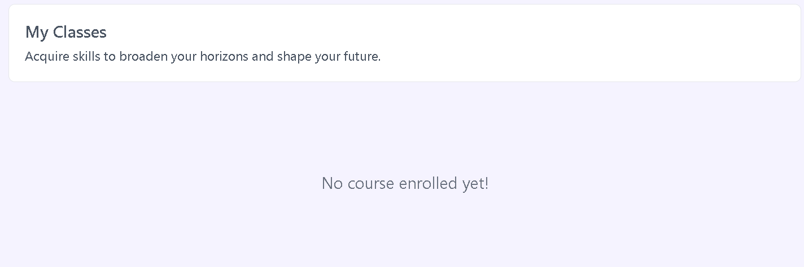

The given code is a React component named MyClasses. It appears to be a part of a web application, presumably displaying enrolled courses and available courses for a user. Let's break down the key aspects of the code:

Component Imports:

The component uses several imports from the React library, such as useState, Link, and useNavigate. Additionally, there are imports for custom hooks (useGetEnrolledAndNotRefund and useGetAllCourses), and other components (PageTitle, Spinner, and ClassContent).

State Initialization:

State is managed using the useState hook. enrolledData and loading are destructured from the result of useGetEnrolledAndNotRefund(), and coursesData is obtained from useGetAllCourses(). The content state is used for conditional rendering.

Course Filtering and Loading Spinner:

The loading state is used to conditionally render a loading spinner (<Spinner />) while waiting for data from the API. The enrolledData is filtered to get enrolled courses (courses) if they exist.

Conditional Rendering:

The component conditionally renders content based on the existence of content. If content exists, it renders the ClassContent component; otherwise, it displays enrolled courses or prompts the user to enroll in a course.

Enrolled Courses Display:

If there are enrolled courses (courses.length !== 0), they are displayed in a grid layout with relevant information and a "Continue Learning" button.

No Enrolled Courses Message:

If there are no enrolled courses, a message is displayed, and if available courses (coursesData.length !== 0) exist, they are presented in a similar grid layout.

Styling:

The component utilizes Tailwind CSS for styling, employing responsive design practices.

**ClassContents**

The given code is a React component named ClassContent, presumably used for displaying content related to a course. Let's break down the key aspects of the code:

Component Imports:

The component imports React, necessary components (PageTitle), and icons from the react-icons/md library.

State Initialization:

State is managed using the useState hook for moduleIndex, videoIndex, and cntIndex to keep track of the currently selected module, video, and content index.

Next and Previous Video Handling:

Functions handleNextVideo and handlePreviousVideo are defined to navigate through the course content. They update the state based on the current module and video indices.

Rendering Course Content:

The component renders course content based on the provided content prop. It displays the course title, total modules, and a dynamic layout for videos, allowing navigation between them.

Button Interaction and Styling:

Buttons for navigating to the next and previous videos are disabled appropriately based on the current state. The styling uses Tailwind CSS classes for a clean and responsive design.

Dynamic Course Content Listing:

The course modules and videos are dynamically listed using the provided data, and a collapsible section is implemented for each module.

Conditional Rendering:

The component includes conditional rendering for cases where there are no videos in the first module or when no modules are present.

Back Button:

A back button is included to navigate to the previous page, and it triggers the setContent function provided as a prop.

Responsive Design:

The layout is designed to be responsive, adjusting the content based on the screen size.